Credit Card
Onboarding
Use Case Document


 | Prepared By / Last Updated By | Reviewed by | Approved By
Name | Person 1 | Person 2 | Person 3
Role | Team Member | Team Member | Scrum Master
Signature
Date

Table of Contents
1.0 Introduction 3
1.1 Purpose & Scope of the document 3
1.2 Intended Audience 3
1.3 Use case ‘User Registration’ 3
1.3.1 Use case attributes 3
1.3.2 Use Case mod 4
1.3.3 Business Rules 4
1.3.4 UI Requirements 5
1.3.5 UI Field Validations 5
1.4 Use case ‘User Credential Authentication’ 6
1.4.1 Use case attributes 6
1.4.2 Use Case Model 7
1.4.3 Business Rules 7
1.4.4 UI Requirements 7
2.0 Database Design 8
2.1 Tables Structure 8
3.0 Change Log 10

Introduction

Purpose & Scope of the document
The purpose of this Use case document is to systematically capture requirements for the project and the system to be developed in terms of use cases. Functional use cases are captured in this document. It also serves as the input for the project scoping.

The scope of this document is limited to addressing the use cases from a user, quality, and non-functional perspective.

Intended Audience
Each member of the project team

Use case ‘User Registration’

Use case attributes
Use Case Description:

This use case deals with the capture of user details. The ‘user’ here shall be the operator of the system and will be keying in the user information into the system.

Scope:

- User registration

Actors:

- User – the operator

Trigger:

Click ‘Submit’ button in the ‘User Registration’ page

Pre-Condition:

User being able to access the homepage & get redirected to the ‘User Registration’ page upon click of ‘Create Application’ link.

Post Condition:

User is in the enrollment page & submit details

Flow of Events:

User at homepage → Click ‘Create Application’ link → User is in the enrollment page → User details are submitted and added onto the database

Primary Scenario:
A new user – is able to click ‘Create Application’ link and able to provide his details and get enrolled in the system.

Use Case Model

Login
Registration
Approval
Check Status

User

Business Rules

Business rules should be defined using the following attributes: -

- When the user clicks on the registration link, it should re-direct to registration form.
    - User needs to fill some of the basic attributes/fields as mentioned below in requirement: First Name, Last Name, Age, Gender, Contact Number, User Id, Password
- Clicking ‘Submit’ should validate the datatype constraints for each field

- Post-successful field level validation, save the information in the database
- Upon saving the information in the database, display the message ‘Your details are submitted successfully’.

UI Requirements
Here is a prototype on how the homepage should look like.

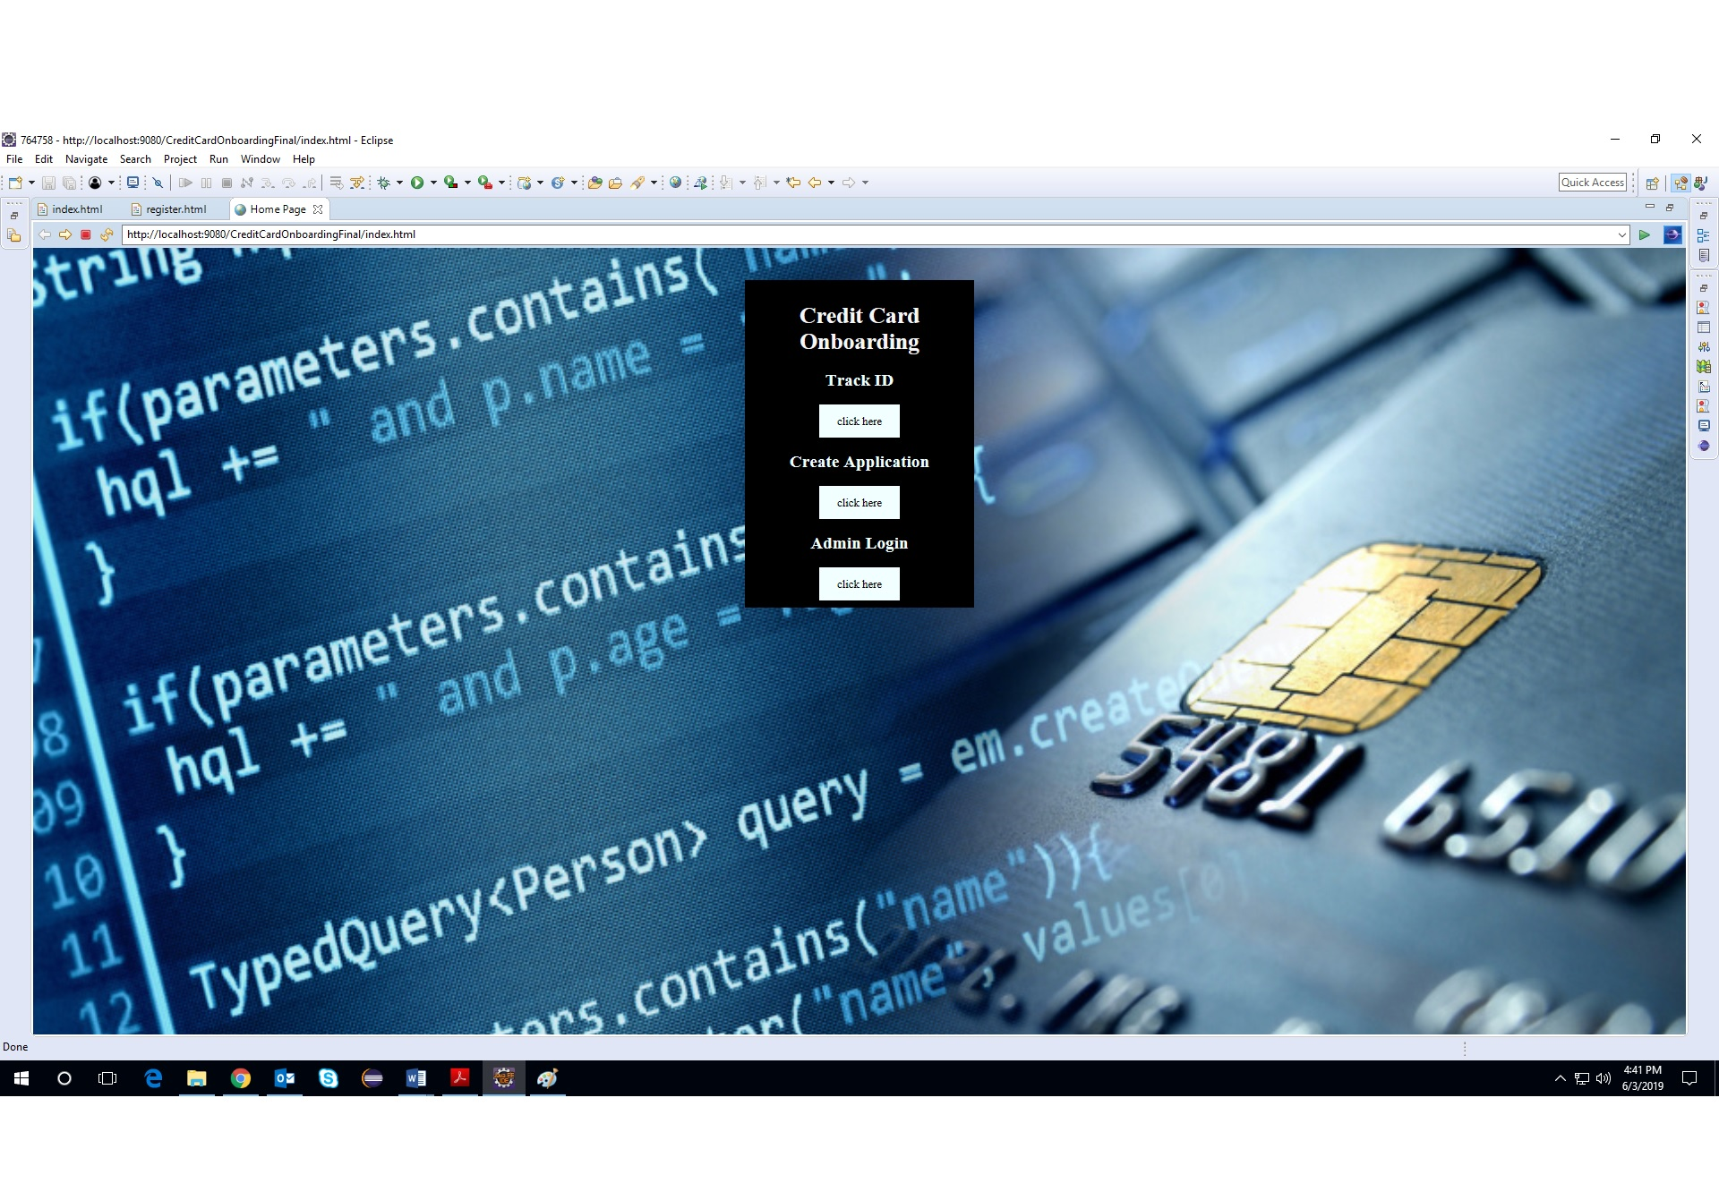

Here is a prototype on how the ‘User Registration’ page should look like.

UI Field Validations
Please refer to the below requirements for field level validations:

- All fields are mandatory.
- Username should be less than 30 chars. Password should have minimum 8 chars, no space & can contain special characters (ex.!,@,#,%,*,& etc.)
- Password and Confirm Password fields should be the same
- The Email ID format must be checked. (For ex. test@testmail.com.)
- Phone Number must be of 10 digits’ length

Use case ‘User Credential Authentication’

Use case attributes
Use Case Description:

This use case deals with the authentication of the user credentials. The ‘user’ here shall be the operator of the system and will be keying in the User information into the system.

Scope:

- User credentials authentication

Actors:

User – the operator

Trigger:

Click ‘Login’ link, after keying in ‘UserID’ & ‘Password’ field.

Pre-Condition:

User being able to access the homepage

Post Condition:

User is in the User Registration page

Flow of Events:

User at homepage → Key in ‘UserID’ & ‘Password’ field → User credentials are validated → User Registration page is displayed

Primary Scenario:
A registered user – is able click ‘Login’ link, after keying in ‘UserID’ & ‘Password’ field and get his credentials authenticated with the existing database entry.

Alternative Scenario:
A registered user – is able click ‘Login’ link, after keying in ‘UserID’ & ‘Password’ field and unable to get his credentials authenticated. The user is presented with relevant error messages:

- Invalid User ID – ‘The userid provided does not exist in our records’
- Incorrect Password – ‘Password provided is incorrect. Please reach out to your system admin.’

Use Case Model
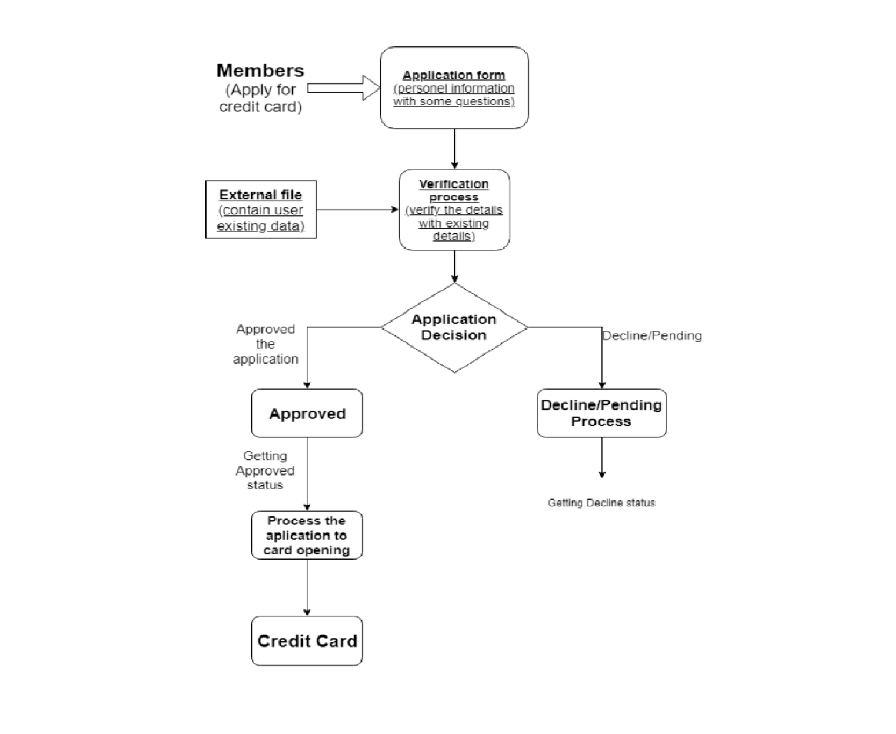

Business Rules
Business rules should be defined using the following attributes:-

- A registered user – is able click ‘Login’ link, after keying in ‘UserID’ & ‘Password’ field and get his credentials authenticated with the existing database entry.

UI Requirements
Here is a prototype on how the User registration should look like.

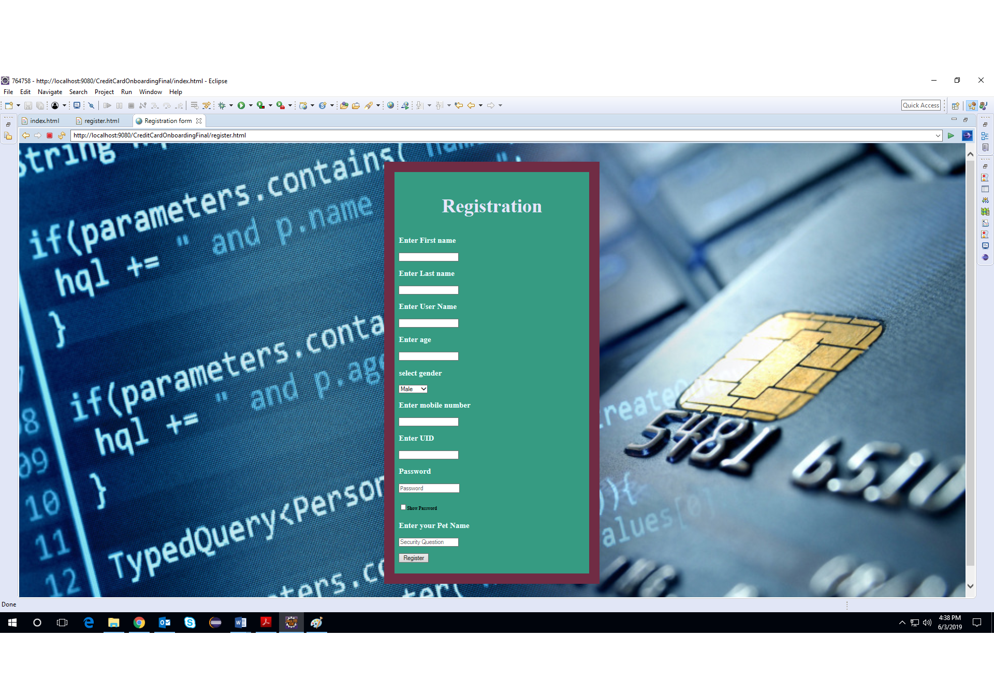

Database Design

Tables Structure
User Registration:
Column Name | Data Type | Length | Nulls
First Name | nvarchar | 50 | N
Last Name | nvarchar | 50 | N
Age | int | 2 | N
Gender | varchar | 10 | N
Contact Number | varchar | 10 | N
Verified | boolean | 1 | N
UID number | int | 20 | N
Password | nvarchar | 15 | N

Application Status:
Column Name | Data Type | Length | Nulls
UID Number | int | 20 | N
Application ID | int | 20 | N
Application Date | nvarchar | 10 | N
Status | NA | NA | NA

Change Log
Version Number | Changes Made
V1.0 | Initial baseline created on <dd-Mon-yy> by <Name of Author>
V1.1 | <Please refer the configuration control tool / change item status form if the details of changes are maintained separately. If not, the template given below needs to be followed>
V1.1 | Section No. | Changed By | Effective Date | Changes Effected

